Task Report

Task Description
In this task we displayed awesomeness by:
    - Discovering the files in the projects directory for researcher2
    - Discovering hidden files in the same directory (as mentioned earlier: awesomeness)
    - Modifying write permissions for project_k.txt
    - Increase hardness by modifying the permissions on a restricted file
    - Modifying permissions on a hidden (archived) file to harden our organizations secuirty posture.
    - Granting read permissions on a hidden file for the user and group.

FSH Navigation
We are logged in to the researcher2 directory and navigating to the projects file. Then,, we list the files/directories in the projects file.

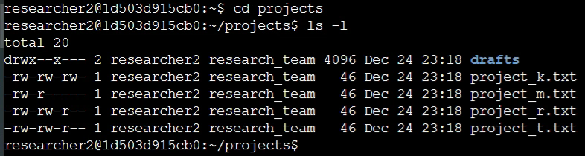

You can see above the permissions string drwx—x--- this is a 10 character string.
- character 1 - indicates if the item is a file (-) or a directory (d)
- characters 2-4 -indicates the permissions for user
- characters 5-7 -indicates the permissions for group
- characters 8-10 -indicates the permissions for others
- the 3 set stings are in the order as follows: read (r) write (w) execute (x) where the letter indicates permission and a dash (-) indicates that the document is protected.
- Read – permission to read the item; Write – permission to edit the item; Execute – permission to run, or open the item
- the following blocks of text indicate the user and group owners of the file, respectively.

Command Semantics
    - cd projects changes the working directory to projects
    - ls -l lists the contents of the working directory (projects), plus includes additional information -l such as the permissions string.

Further Directory Investigation
This scenario demands the knowledge of hidden files.

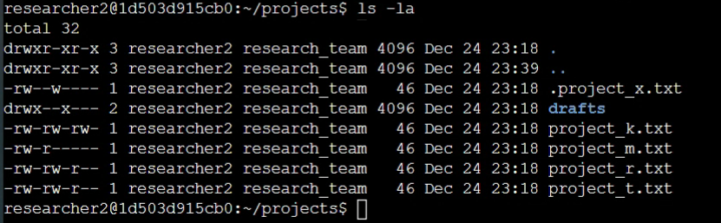

Command Semantics
    - ls -la Populates the list of files and directories in the logs directory
          - ls WITH -l provides additional information about the files and directories listed such as permissions and owners.
          - ls WITH -a includes hidden files with the list of files and directories.

NOTE: We find a hidden file, indicated with a “.” preceding the file name.

Adjusting Permissions
No item in the Projects directory should have write permissions for other users. What we found above, using the ls -la command, demands that we change write permissions for the “project_k.txt” file.

After the chmod command is where the permissions command is placed. There are several permissions modifiers. In this instance we are subtracting (-) write (w) permissions from the other (o) string

Command Semantics
    - chmmod o-w project_k.txt this command modifies the permissions of our project_k.txt file to ensure that the file is protected from other users having write permissions
    - chmod [permissions] [file/directory]

Modifying Restricted File Permissions
The demands of a restricted file are showcased here. “project_m.txt” is a restricted file. It is discovered that we must harden the organization's the security concerning this particular file by ensuring that only the user has read and write permissions on the file. A previous screenshot (2 shots back) shows that the group has read permissions on the restricted file.

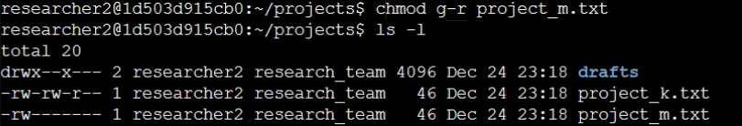

Command Semantics
    - chmod g-r project_m.txt chmod indicates that a file permissions modification will be made; g indicates that the modication will be made to the group string; - indicates that (a) permission(s) will be protected; and finally r indicates that the read permissions will be modified in this way.
    - ls -l helps us check our work. We see that the “m” file and the “k” file both have the permissions that our security posture goals demand.

Modifying Hidden File Permissions
We discover that a hidden file has permissions that do not line up with security protocol. We adjust the permissions of the hidden file.

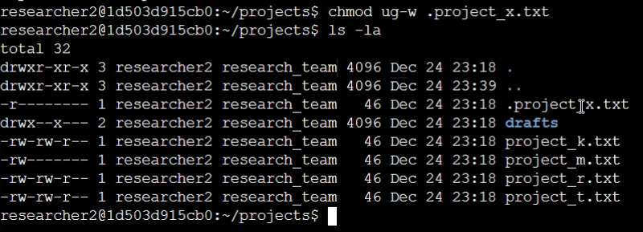

Additional technical info concerning the command used or information displayed in the screenshot

Command Semantics
    - ls -la Populates the list of files and directories in the logs directory
          - ls WITH -l provides additional information about the files and directories listed such as permissions and owners.
          - ls WITH -a includes hidden files with the list of files and directories.
    - chmod ug-w .project_x.txt ug indicates that the user and group strings will be modified; - indicates that the modifier is to protect the archived file; and finally the w indicates that the write permissions will be modified. This leaves the archived file “x” with only read permissions on the user and group and no permissions for other users. This as indicated by the string “-r--------” on the .project_x.txt file line.

NOTE: the “.” preceding the hidden file.

Granting Permission
The previous task protected permissions; however, as indicated previously both the user and the group need read access to hidden “project_x.txt” file. We grant that access in this step.

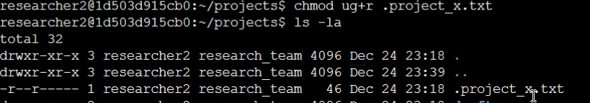

Additional technical info concerning the command used or information displayed in the screenshot

Command Semantics
    - chmod ug+r .project_x.txt The u command is unnecessary here as the user already had read permissions, however it did not effect the outcome in a negative way. This command produced read permissions on the “.project_x.txt” file for the user and group.

Summary
Various modifications were made to harden the security posture of the organization, thus showcasing two of the chmod applications, including protecting and granting permissions for both hidden and non-hidden files, as well as restricting access to to a restricted file. These are examples of daily tasks, which I completed, that a typical Cybersecurity Engineer will be completing in order to protect a company's assets and ensure the company is not so restricted that its members are unable to function.

The report could have been made longer, but out of respect for your time I truncated the final tasks associated with this work load. Those tasks included modifying permissions on directories, further cultivating a salubrious digital environment for the members of the organization. You know, generally being awesome. Like hot wings. I mean really hot wings – those are awesome too, don't you agree? Well, speaking of hot wings...

God bless the work of your hands.

